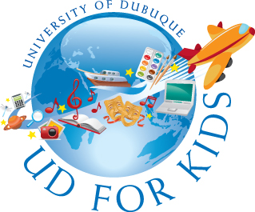

As UD for Kids enters its 33rd year, I am excited to send you information about the University of Dubuque’s summer program for students.

- All students who have completed grades 1-7 and have interest in participating are eligible to attend.
- A variety of courses are offered to build reading and math skills in the areas of science, math, technology, engineering, visual and performing arts, aviation, and culinary arts.
- The fee for the program is $160.00 per session. This includes all class materials, a daily snack, and a UD for Kids t-shirt.
- To participate, parents must complete an application form prior to class registration. This form is currently available and can be found on the UD for Kids website, http://www.dbq.edu/udforkids.
- Course selection and payment of the required fee will occur on class registration day, April 12. Instructions for class selection and fee payment will be on the UD for Kids website.
- As always, appropriate health and safety measures will be implemented during the weeks of class. These will include:
- encouraging hand washing and use of hand sanitizer,
- capping class size at 16 students or less,
- adult supervision at all times.

The wearing of a face covering for health reasons is a family/student choice. Face coverings are encouraged if health is a concern.

- Updates and information will be posted on the UD for Kids website in the coming weeks. Please monitor regularly to stay current.
The 2025 dates for UD for Kids are:
- Session one - June 16-20, for current first & second grade students;
- Session two - June 23-27, for current third & fourth grade students;
- Session three - July 7-11, for current fifth, sixth & seventh grade students.

Students in sessions 1 and 2 will select two classes from a variety of choices. Students in session 3 will select one class. Classes are held from 12:30-4:00 p.m. on the University of Dubuque campus, unless otherwise designated in the class description.

Some classes for 5th-7th grade students do run during the first and/or second sessions. These classes, and all others for this age group are listed under session 3 classes, July 7-11. If class dates are different from July 7-11 it will be clearly stated in the class description.

Join us in our 33nd year of enrichment for tri-state students. We look forward to seeing you on the beautiful University of Dubuque campus this summer!

Peggy Driscoll Director, UD for Kids 2025 Email: udkids@dbq.edu

